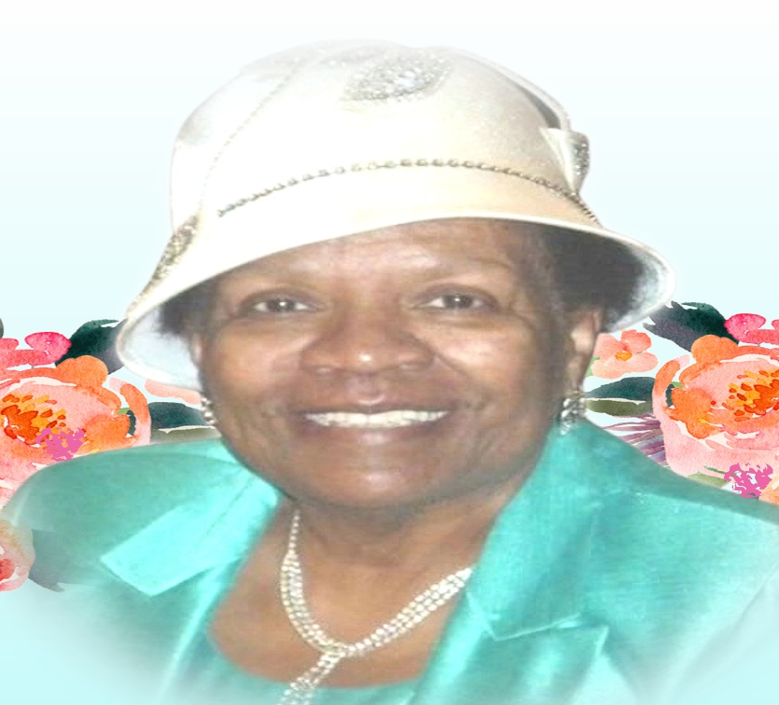
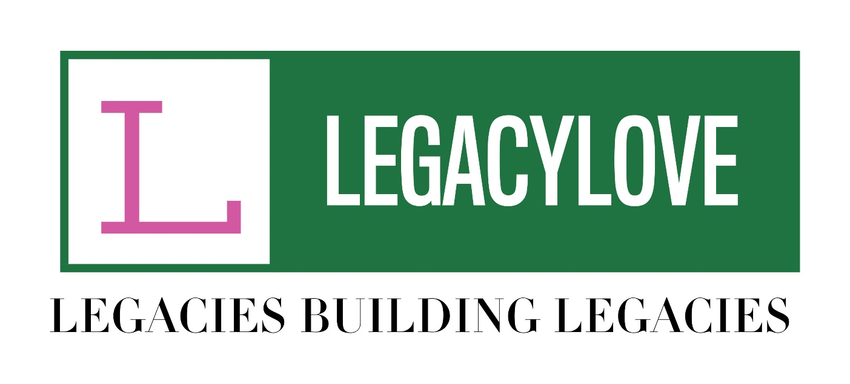

CELIA V. CARR
SCHOLARSHIP INFORMATION PACKET
Deadline: JUNE 1, 2022
(For Howard County, Baltimore County & Baltimore City High School Seniors)
Dear Scholarship Candidate:
The mission of LegacyLove Inc. is to inspire, support, mentor and provide resources for students as they become productive and independent citizens in our society. This scholarship is being awarded in honor of Celia V. Carr, who was a lifelong educator and loved to see young people excel. Our organization strives to support the goals of young people by offering a scholarship to deserving First Generation College Students (FGCS) each year. This means that your mother and/or father did not obtain a bachelor’s degree from a 4-year college or university. This is a notable accomplishment for you as well as for your family. Applicants for this $1000 scholarship must meet the eligibility criteria of being a First-Generation College Student, have a minimum GPA of 2.5 along with acceptance into 4-year college/university. You must also complete the Application Form and submit all required documentation by JUNE 1, 2022. Your completed application packet must include:
- A typed Application Form
- A Recent Photograph (Head Shot Preferred)
- An official copy of your high school transcript
- Two letters of recommendation (one from a teacher/guidance counselor and one from a community service organization/church). Each letter must be typed on official letterhead. A daytime contact number and signature of the person writing the recommendation are required for both letters. NO HANDWRITTEN LETTERS WILL BE ACCEPTED
- Essay (500 Words) – Your essay must include your future aspirations and what you have done and/or plan to do to reach your goals. Your essay must be typed and can be submitted as added pages or an attachment to this packet.
- Letter of Acceptance
- A notarized letter from your mother and/or father documenting they did not receive a bachelor’s degree from a 4 year college/university.

All completed, neatly typed packets must be returned to the Scholarship Committee by Wednesday, June 1, 2022. There will be NO EXCEPTIONS TO THE DEADLINE. The Scholarship Committee members will review the applications and notify you if you are selected by June 30, 2022. Your application can be submitted by email to support@legacylove.net or faxed to 443.526.6924. Scholarship funds will be sent to the school you will be attending. If you have any questions, please call 443.913.3910 or email the Scholarship Committee at support@legacylove.net.
Sincerely,
The Scholarship Committee

APPLICATION FORM
(MUST BE TYPED – NO EXCEPTIONS)
Current High School:
PART I. PERSONAL INFORMATION
Applicant’s Full Name:
Address:

City: State: Zip Code:

Telephone Number:
E-Mail:

Name of Parents/Guardian:

Grade Point Average:

Program of Study:

PART II. COLLEGE ENROLLMENT DATA:
Name of college you plan to attend:
Address:

City: State: Zip Code:

Will you be a First Generation College Student? _______
Have you been accepted into the college you have listed? _______
What will be your major? _______________________________________
PART III.
List on the lines below, any extra-curricular activities you participated in while in high school. Please be sure to indicate the years participated, offices held or committees served on.

PART IV.
List on the lines below, any awards, honors and/or significant achievements or accomplishments.

APPLICATION CHECKLIST
HAVE YOU:
- Ensured your application is typed neatly
- Enclosed a photograph with your application
- Included your High School Transcript {1st Semester}
- Included two (2) letters of recommendation {One from teacher/guidance counselor and one from community organization/church you have been involved with}
- Included your Essay
- Included your Acceptance letter from college (may be added as attachment)
- Completed ALL information on Application Form

